1.0 Install a DHCP Server by Powershell

2.0 Create a new Scope called VLAN1 192.168.1.0

3.0 Create a new range of 192.168.1.1-192.168.1.254

4.0 Exclude the first 15 IP addresses 192.168.1.1-192.168.1.15

5.0 Authorize the server to run in an ADDS

6.0 Ensure the DHCP Server lease IP address.

**NOTE:** Everything must be done by **PowerShell**

1. 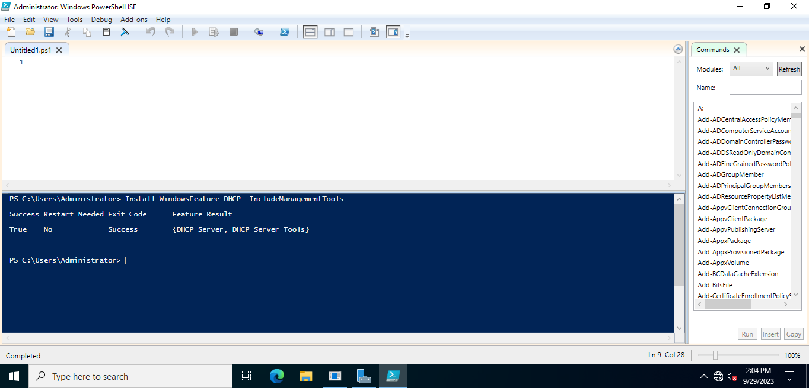Print screen of DHCP Server is installed

2.0 Print Screen of Scope is called VLAN10

3.0 Print Screen of a new Range 192.168.1.1-192.168.1.254

4.0 Print Screen of DHCP server is authorized in ADDS

5.0 Print Screen of Users leasing Ip address

